**Wrapper classes** are used to convert any data type into an object.

The wrapper classes in java servers two primary purposes.

* To provide a mechanism to ‘wrap’ primitive values in an object so that primitives can do activities reserved for the objects like being added to ArrayList, Hashset, HashMap etc. collection.
* To provide an assortment of utility functions for primitives like converting primitive types to and from string objects, converting to various bases like binary, octal or hexadecimal, or comparing various objects.

Below table lists wrapper classes in Java API with constructor details.

|  |  |  |
| --- | --- | --- |
| **Primitive** | **Wrapper Class** | **Constructor Argument** |
| boolean | Boolean | boolean or String |
| byte | Byte | byte or String |
| char | Character | char |
| int | Integer | int or String |
| float | Float | float, double or String |
| double | Double | double or String |
| long | Long | long or String |
| short | Short | short or String |

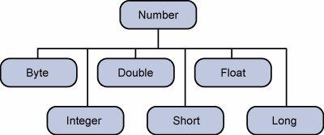

**class** Demo_Wrap

{

**public** **static** **void** main(String[] args)

{

Integer i = **new** Integer(12);

System.***out***.println(i);

*modify*(i);

System.***out***.println(i);

}

**private** **static** **void** modify(Integer i)

{

i = i + 1;

}

}

**Output**

12

12